1. What is PT?  
   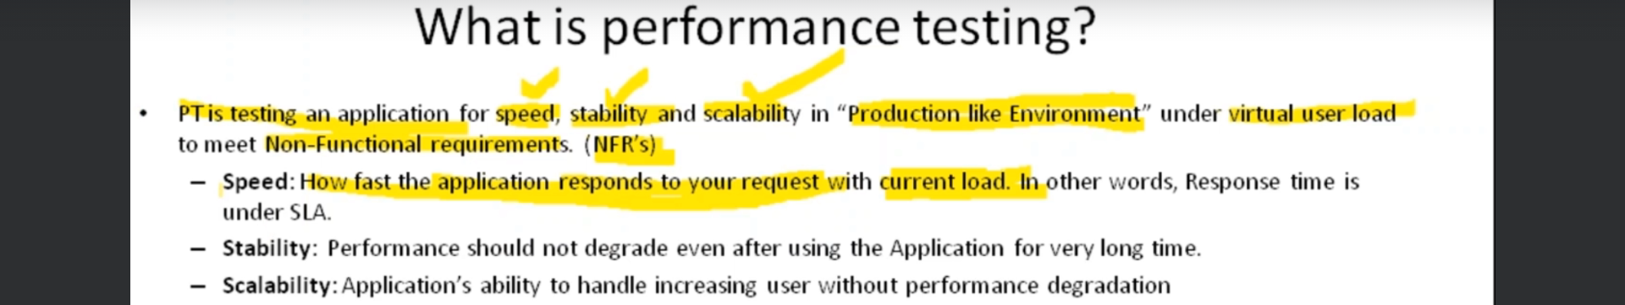
2. Let’s try to understand the three terms 🡺 Speed, Stability, & Scalability
3. Before that, let us pay attention to that in any application, there is a number of different kinds of transactions like login, logout, Compose Email, Send Email etc. For all the kind of transaction, the SLA must be same means the max response time must be 2 seconds.
4. **Speed**:
   1. Let’s suppose mark has 5 family members including Mark.
   2. Mark wants to go on a tour with his all members on **his car**.
   3. So, the current load is 5.
   4. Now, with the current load (5) which is **current peak load**, we want to see if the car is driving fast or not.
   5. Similarly, we want to test our app that it is fast enough under current load.
   6. Fast enough means that it is meeting the **SLA** = **S**ervice **L**evel **A**greement (2 seconds).
5. Till 1980, the definition of PT was restricted only to SPEED but now it includes stability and scalability.
6. **Stability**:
   1. Now Mark is going only with 3 family members (even though they are 5 in total) but for a long enough drive.
   2. **NOTE**: Current load (3) is less than Peak Load (5).
   3. Now, he wants to check if over a period of time, its speed not decreasing means its speed is sustained and the car does not break down.
   4. **NOTE**: So, here Current Peak Load is not required.
   5. Same, we want with our app. If deployed today, the same performance we want after 10 months.
7. NOTE: **Scalability we will discuss in the next lecture.**